### Altai IX500 Indoor 2×2 802.11ac Wave 2 AP

### Administrator weak password

#### 1、Product attribution and introduction：

https://www.altaitechnologies.com/portfolio-item/indoor-ix500/

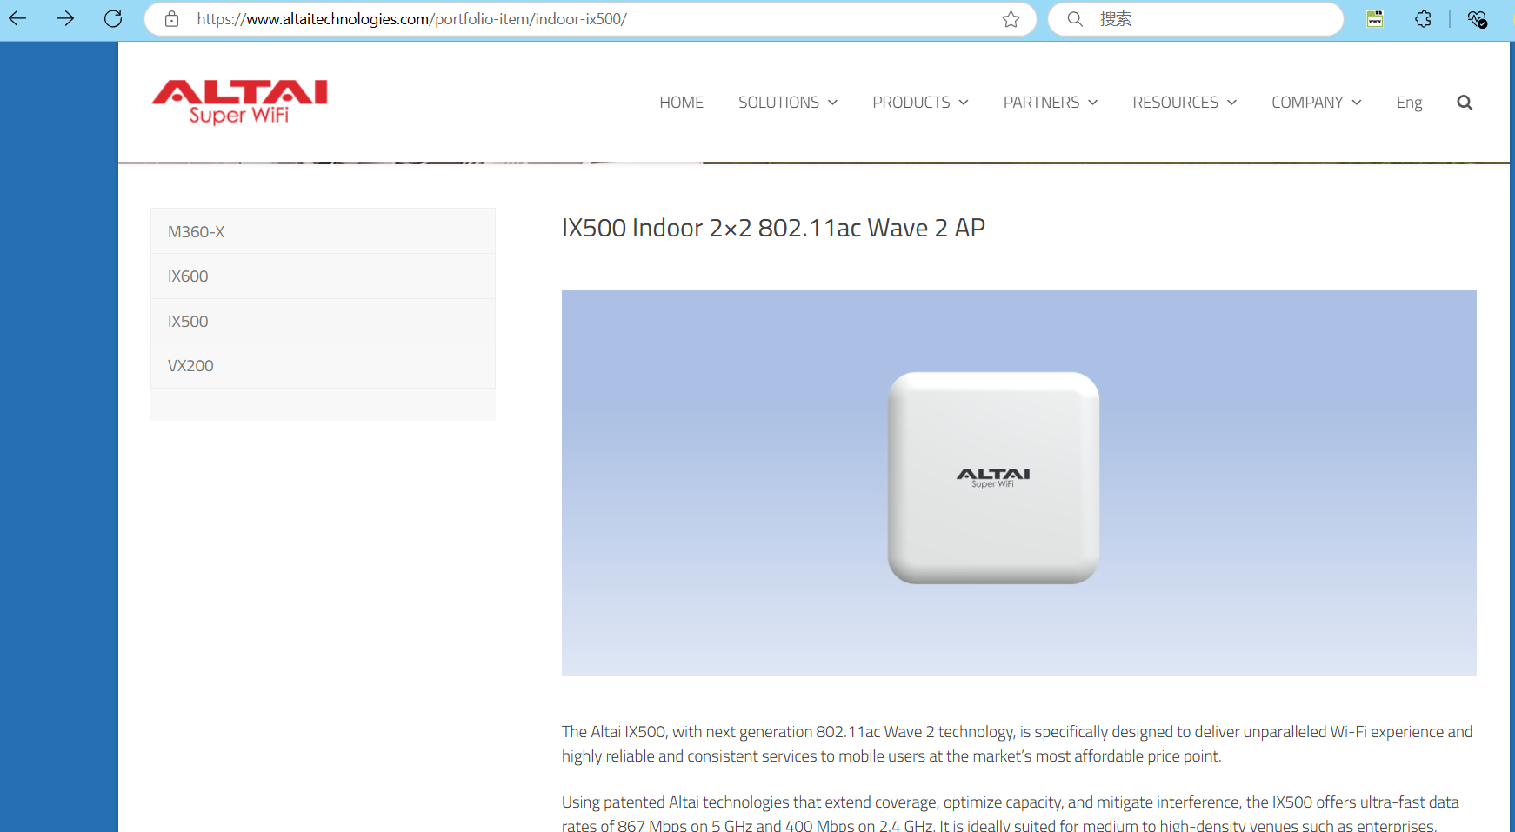

#### 2、Vulnerability description

IX500 Indoor 2×2 802.11ac Wave 2 AP web Management Weak password（admin/admin） leakage in the background may lead to unauthorized access, data theft, and network attacks, seriously threatening network security.

#### 3、Example

username/password：admin/admin

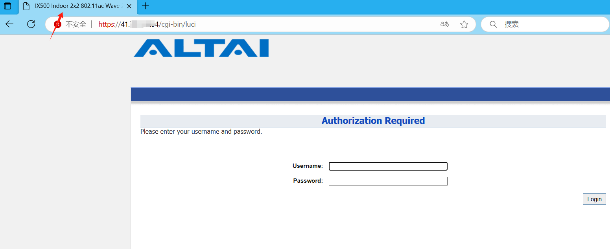

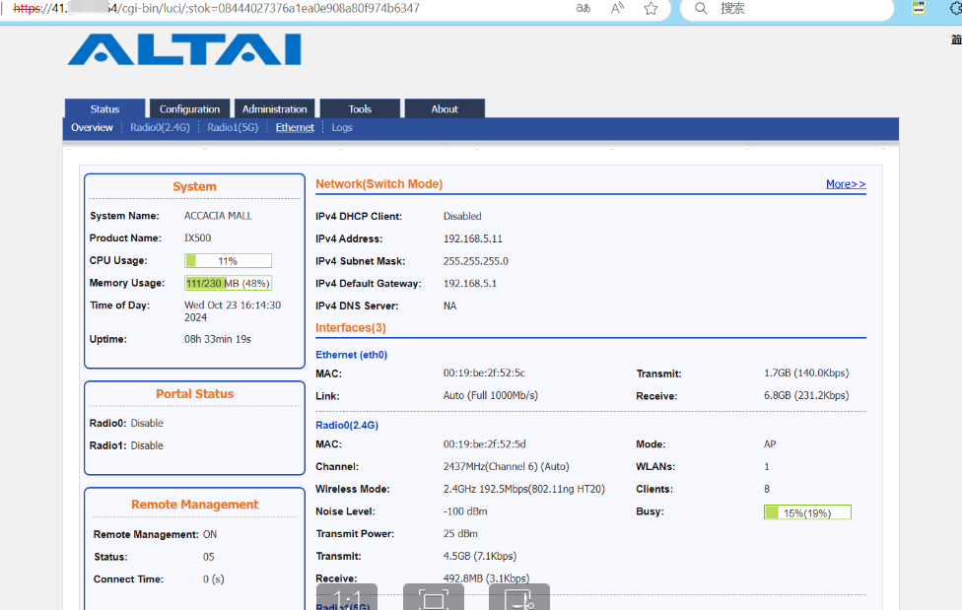

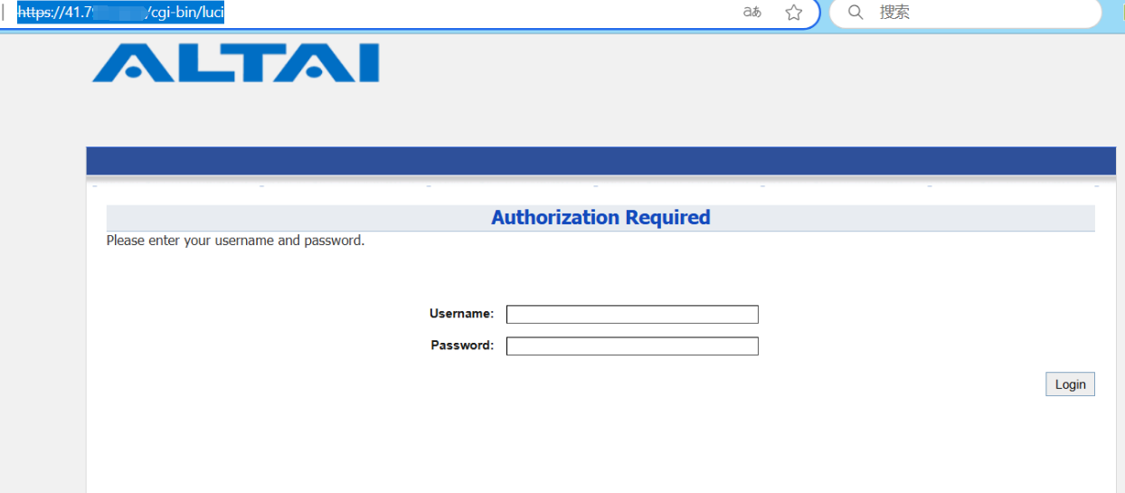

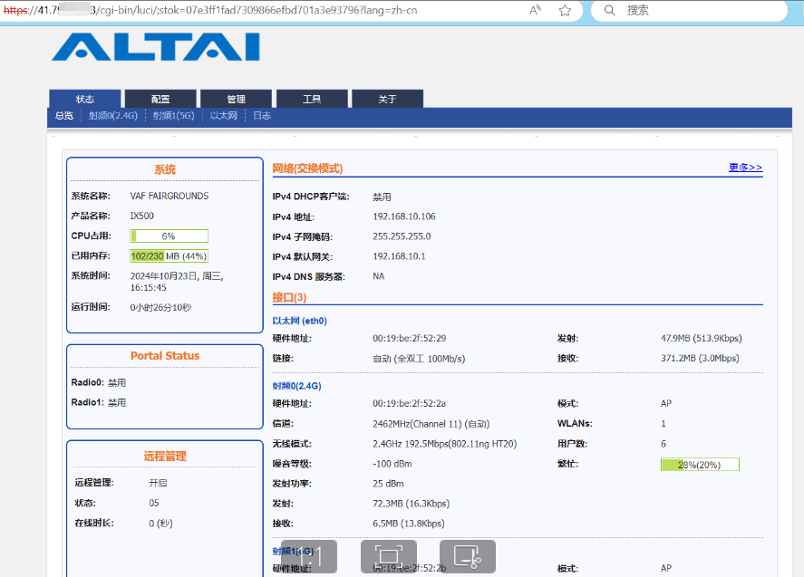

#### 4、Nuclei ：

